**PROJECT REPORT OF**

**DATA BASE MANAGEMENT SYSTEMS**

**(CE-301)**

**PROJECT TITLE**

**KMC (Karachi Metropolitan Corporation) Truck booking Android Application.**

**SPRING SEMESTER 2019**



### **SUBMITTED BY:**

**Sheikh Muhammad Adeel (2017-CE-093)**

**Muhammad Taha Ehtisham Khan (2017-CE-086)**

**Mohammad Jibran Alam (2017-CE-064)**

**Muhammad Sabih uddin (2017-CE-085)**

**Muhammad Shoaib (2017-CE-104)**

### **Computer Engineering Department**

**Sir Syed University of Engineering & Technology**

**University Road, Karachi 75300**

|  |  |  |  |  |
| --- | --- | --- | --- | --- |
|  | | | | |
| **PROJECT INDEX** | | | | |
| **Student Name:** | | | **Roll No.:** | **2017-CE-93**  **2017-CE-86**  **2017-CE-64**  **2017-CE-85**  **2017-CE-104** |
| **Section :** | **B** |
| **Head #** | **Date** | **Project Description** | **Signature** | **Remarks** |
| 1 | 18-3-19 | PROJECT TITLE |  |  |
|  |
|  |
| 2 | 18-3-19 | PROJECT DISCRIPTION |  |  |
|  |
|  |
| 3 | 18-3-19 | SCREEN SHOTS |  |  |
|  |
|  |
|  |  |  |  |  |
|  |
|  |
|  |  |  |  |  |
|  |
|  |
|  |  |  |  |  |
|  |

**PROJECT TITLE**

KMC (Karachi Metropolitan Corporation) Truck booking Android Application.

**DISCRIPTION:**

This is an android application developed on android studio for booking KMC truck As a Driver and Citizen track each other. This app is consisting on Login page where existing Id log in. If driver or Citizen don’t have any id another option for create account as a citizen and driver. After login citizen send the request to the truck driver accept the request after accepting both are tracking each other.

**SCREEN SHOTS:**

**Login Form:**

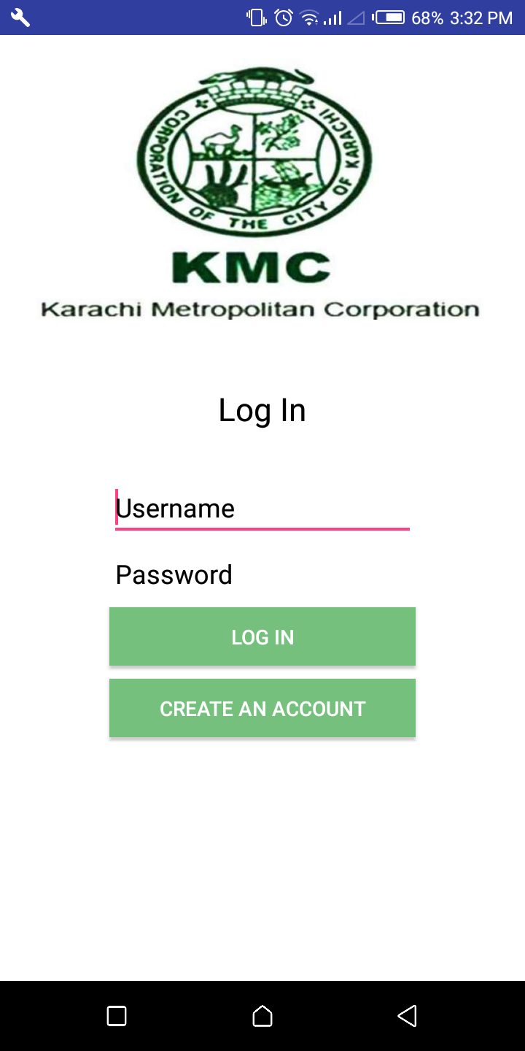

**Creating Account:**

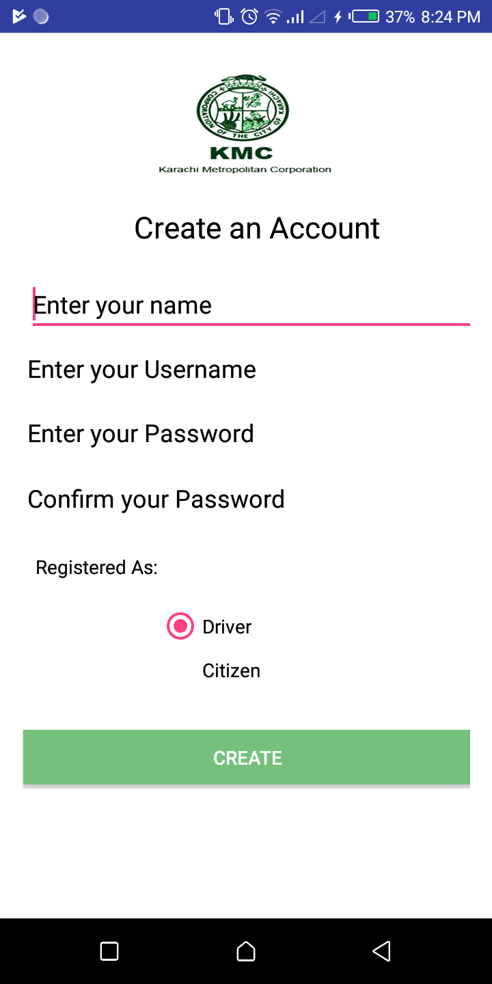

**Login as Citizen:**

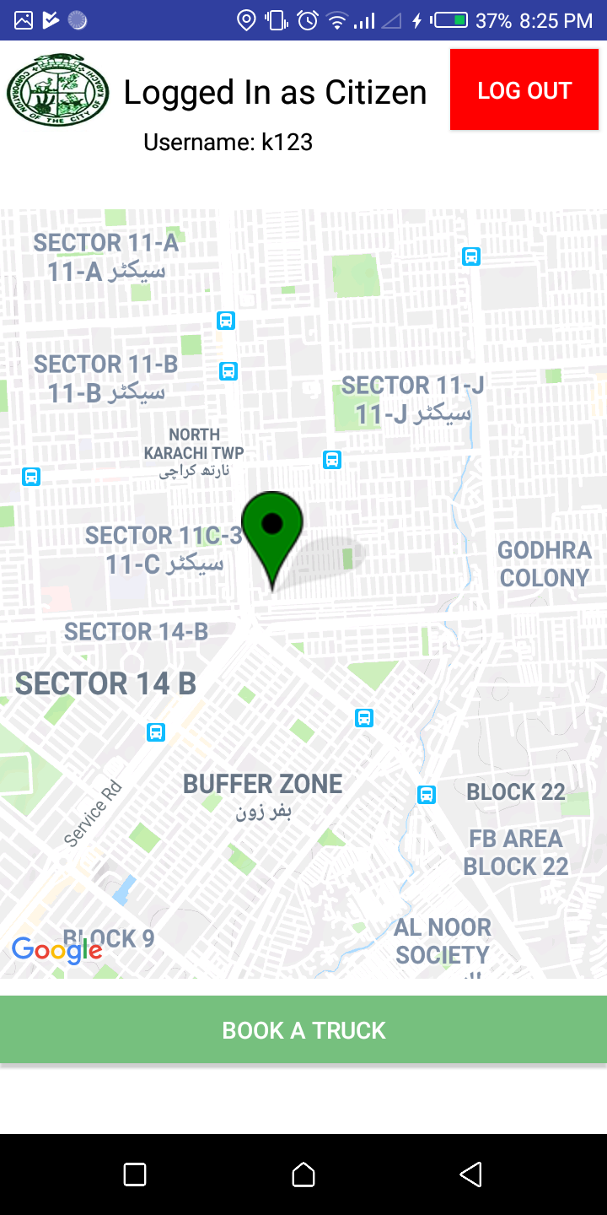

**Waiting for driver to accept his request**

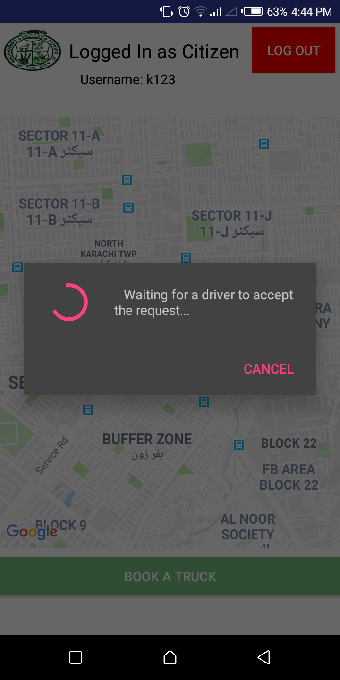

**Logged in as Driver:**

